UNITED STATES
SECURITIES AND EXCHANGE COMMISSION
Washington, D.C. 20549

SCHEDULE 14A

Proxy Statement Pursuant to Section 14(a) of
the Securities Exchange Act of 1934 (Amendment No. )

Filed by the Registrant x

Filed by a Party other than the Registrant ☐

Check the appropriate box:

 |  |  | ☐ |  |  | Preliminary Proxy Statement

 |  |  | ☐ |  |  | Confidential, for Use of the Commission Only (as permitted by Rule 14a-6(e)(2))

 |  |  | ☐ |  |  | Definitive Proxy Statement

 |  |  | x |  |  | Definitive Additional Materials

 |  |  | ☐ |  |  | Soliciting Material under §240.14a-12

HealthEquity, Inc.
(Name of Registrant as Specified In Its Charter)
(Name of Person(s) Filing Proxy Statement, if other than the Registrant)

Payment of Filing Fee (Check the appropriate box):

 |  |  | x |  |  | No fee required.

 |  |  | ☐ |  |  | Fee paid previously with preliminary materials.

 |  |  | ☐ |  |  | Fee computed on table in exhibit required by Item 25(b) per Exchange Act Rules 14a6(i)(1) and 0-11

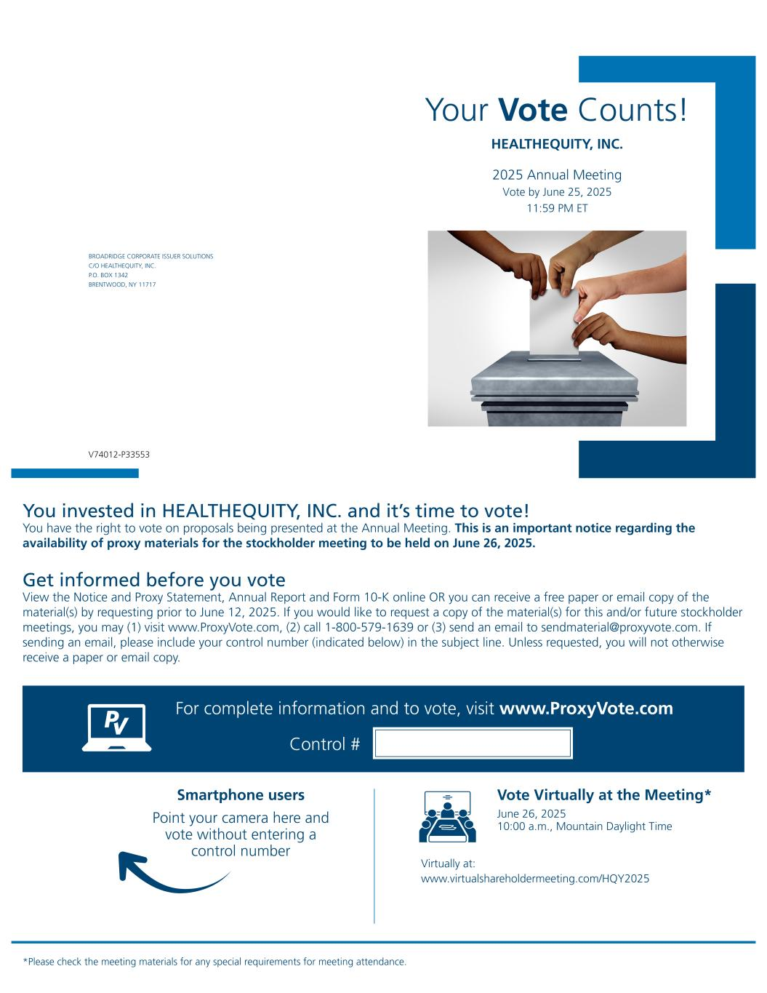

Your Vote Counts! *Please check the meeting materials for any special requirements for meeting attendance. Smartphone users Point your camera here and vote without entering a control number For complete information and to vote, visit www.ProxyVote.com Control # V74012-P33553 BROADRIDGE CORPORATE ISSUER SOLUTIONS C/O HEALTHEQUITY, INC. P.O. BOX 1342 BRENTWOOD, NY 11717 HEALTHEQUITY, INC. 2025 Annual Meeting Vote by June 25, 2025 11:59 PM ET You invested in HEALTHEQUITY, INC. and it’s time to vote! You have the right to vote on proposals being presented at the Annual Meeting. This is an important notice regarding the availability of proxy materials for the stockholder meeting to be held on June 26, 2025. Get informed before you vote View the Notice and Proxy Statement, Annual Report and Form 10-K online OR you can receive a free paper or email copy of the material(s) by requesting prior to June 12, 2025. If you would like to request a copy of the material(s) for this and/or future stockholder meetings, you may (1) visit www.ProxyVote.com, (2) call 1-800-579-1639 or (3) send an email to sendmaterial@proxyvote.com. If sending an email, please include your control number (indicated below) in the subject line. Unless requested, you will not otherwise receive a paper or email copy. Vote Virtually at the Meeting* June 26, 2025 10:00 a.m., Mountain Daylight Time Virtually at: www.virtualshareholdermeeting.com/HQY2025

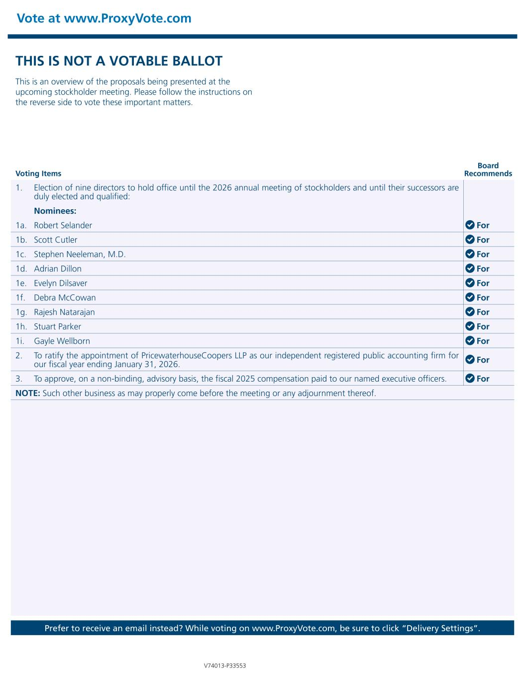
Vote at www.ProxyVote.com Prefer to receive an email instead? While voting on www.ProxyVote.com, be sure to click “Delivery Settings”. Voting Items Board Recommends V74013-P33553 THIS IS NOT A VOTABLE BALLOT This is an overview of the proposals being presented at the upcoming stockholder meeting. Please follow the instructions on the reverse side to vote these important matters. 1. Election of nine directors to hold office until the 2026 annual meeting of stockholders and until their successors are duly elected and qualified: Nominees: 1a. Robert Selander For 1b. Scott Cutler For 1c. Stephen Neeleman, M.D. For 1d. Adrian Dillon For 1e. Evelyn Dilsaver For 1f. Debra McCowan For 1g. Rajesh Natarajan For 1h. Stuart Parker For 1i. Gayle Wellborn For 2. To ratify the appointment of PricewaterhouseCoopers LLP as our independent registered public accounting firm for our fiscal year ending January 31, 2026. For 3. To approve, on a non-binding, advisory basis, the fiscal 2025 compensation paid to our named executive officers. For NOTE: Such other business as may properly come before the meeting or any adjournment thereof.

